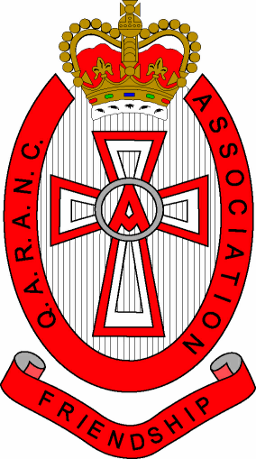
Queen Alexandra’s Royal Army Nursing Corps Association
Charitable Incorporated Organisation - 1163821

AGENDA

Annual General Meeting – (Insert Name) Branch
To be held at (Insert place) on (Insert date) at (insert time)

Serial | Item | Lead
1 | Welcome and apologies for absence | Chairperson
2 | Notice Convening Meeting | Secretary
3 | Conflict of Interest/Loyalty Declaration | Chairperson
4. | Minutes from last meeting | Chairperson
5. | Matters arising from minutes from last meeting | Chairperson
6. | Chairmans Report  To include feedback for meetings at RHQ etc  To include number of Branch Members and activity undertaken in support of Objects over the year | Chairperson
7. | Presentation of Inspected Accounts for previous financial year  (Vote to be taken by AGM attendees to confirm approval of accounts) | Treasurer
8. | Confirmation/Re-election of Committee  An update on post holders and their tenure should be given.  A vote should then be held for any vacant appointments. The appointee will be decided on a simple majority of those present. | Chairman
9. | Forecast of Events | Secretary
10. | Date of Next meeting | Secretary

